Team Name:
Team 57
Team
Department: computer science

Name: N.Srikar
Roll No: 19131A05G1
Mail:19131a05g1@gvpce.ac.in
Mobile:9491673788

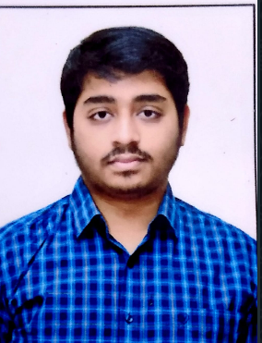
Name: P.Divya Gandh
Roll No: 19131A05H7
Mail:19131a05h7@gvpce.ac.in
Mobile: 7995376867
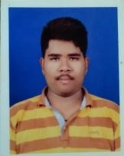
Name: P. Harsha Vardhan
RollNo:19131a05H4
Mail:19131a05h4@gvpce.ac.in
Mobile:9010248999


Name: Nitin Ancha
Roll No:19131A05G0
Mail:19131a05g0 @gvpce.ac.in
Mobile:9346625657


Project Guide
Name: Dr. H Prthsarathi Patra
Mail:hparthasarathi@gvpce.ac.in
Mobile: 9861012411


Abstract
We all know that to run a business customers are important. The business people believe that “customers should be treated as Gods”. To maintain relationship between customer and owner and their trust is more important to run a business for long term. Here we get a solution for that, using our Customer Segmentation that company could know about the customer and produce products, give special offers and act according to customer needs, so there would be a great relationship between customer and owner. We used Machine Learning in R, we visualize and analyse the data based on age, gender, income and spending score. We also use clustering Techniques. We try increase the clusters of customers for more analysis.

Domains where our solution can be implemented
Companies,Business,Dealers, etc;

Our solution helping the selected domains
The companies, businesses, dealers etc, who are selling or sells products get benefit of our project

Our engineering solution
Using Machine Learning Customer Segmentation to know about customers analysis on products, based on age, income, gender and spending score.

.

Team’s vision
Our main vision is to segment customers and make easy to companies to release products and offers according to that data.

Signature of Project Guide:

